

FACULTY: Information Technology
COURSE: Multivariable Calculus and Differential Equations
COURSE CODE: MATH8213
ACADEMIC YEAR: 2025 – 2026
TEAM: 1
VENUE : Gishushu Campus
LECTURER: NIZEYIMANA Viateur
SEMESTER : 1

ID | Names | Date of Meeting | Signature
26432 | Ntaganira Habimana Happy (Chief) | 10/08/2025
24122 | Mukama Yves Thomas | 10/08/2025
24673 | Kambale Kiregha Ezechiel (Sec) | 10/08/2025
24889 | Bideri Alec | 10/08/2025
25051 | Mugiraneza Mugabo Octave | 10/08/2025
25234 | Ndeko Kaduli Jordan | 10/08/2025
26233 | Jarwin W Monboe | 10/08/2025
26317 | Ishimwe Bienvenu | 10/08/2025
26439 | Niyonkuru Arnold | 10/08/2025
26505 | Shema Jean Baptist | 10/08/2025
27354 | Munyaneza Manzi Sarto | 10/08/2025
27380 | Mushirarungu Ghislaine | 10/08/2025
27388 | Bakwiye Massa Patience | 10/08/2025
27404 | Uwera Cynthia Carmella | 10/08/2025
27409 | Teta Allen | 10/08/2025
28236 | Ineza Semuhungu Joel | 10/08/2025
28240 | Rukimirana Olivier | 10/08/2025
29061 | Mutangana Joseph | 10/08/2025
26314 | Nishimwe Diane | 10/08/2025

$$MULTIVARIABLE ASSIGNEMENT \#1$$
Q1.In 2D affine space endowed with orthonormal frame, given a triangle with vertices

$$1. Vertices: A (4,4), B (-6, -1), C (-2,4)$$
$\vec{AB}= (-6-4, -1-4) = (-10, -5)$
$\vec{AC} = (-2-4, 4-4) = (-6, 0)$
$$\vec{BC} =\left(-2+6, 4+1\right)=(4,5)$$
$$c=|\vec{AB}|= \sqrt{{(-10)}^{2 }+{(5)}^{2}} =\sqrt{125 }= 5\sqrt{5}$$
$$b=|\vec{AC}|= \sqrt{{(-6)}^{2 }+{(0)}^{2}} =\sqrt{36 }=6$$
$$a= |\vec{BC}|= \sqrt{{(4)}^{2 }+{(5)}^{2}} =\sqrt{41 }=6.4$$

$$i) Perimeter (P)=a+b+c$$
$$P=11.1+6+6.4=23.5$$
$ii) Area= \frac{1}{2}\left[-6-4 -1-4 -2-4 4-4 \right]$
$$Area= \frac{1}{2}\left[-10 -5 -6 0 \right]$$
$$Area= \frac{1}{2}\left(0-30\right)=15 (Square unit$$
$$iii) Angle at (A)$$
$\vec{AB}. \vec{AC }=\left(-10\right)\left(-6\right)+\left(-5\right). 0=60$
$$\vec{\left|AB\right|}= \sqrt{{(-10)}^{2 }+{(5)}^{2}}=5\sqrt{5}$$
$$\vec{\left|AC\right|}= \sqrt{{(-6)}^{2 }+{(0)}^{2}} =\sqrt{36 }=6$$
$$Cos A= \frac{60}{5\sqrt{5}*6}=0.894427191$$
$$A= {26.56}^{o}$$
$$iv) Angle at \left(B\right) between \vec{BA} and \vec{BC }$$
$\vec{BA}. \vec{BC }=\left(10\right)\left(4\right)+\left(5\right)(5)=65$
$$\vec{\left|BA\right|}= \sqrt{{(-10)}^{2 }+{(5)}^{2}}=5\sqrt{5}$$
$$\vec{\left|BC\right|}= \sqrt{{(4)}^{2 }+{(5)}^{2}} =\sqrt{41 }$$
$$Cos B= \frac{65}{5\sqrt{5}*\sqrt{41}}=0.9079593845$$
$$B={24.78}^{o}$$

C) $Angle at C={180}^{o}-(A+B)$

$$Angle at C={180}^{o}-({26.56}^{o}+{24.78}^{o})$$
$$C={128.66}^{o}$$

$$2. (8) Equations of Line AC = b$$
$$Vectors A (4,4), C (-2,4)$$
$$i) Vector Equation$$
$$let P(x,y) be any point$$
$$\vec{AP }= τ\vec{AC}$$
$$ii) Parametric Equation$$
$$\vec{AC} = (-2-4, 4-4) = (-6, 0)$$
$$\left(x-4 y-4 \right)= τ\left(-6 0 \right)= x=4-τ6 y=4$$
$$iii) Canonical Equation$$
$$\frac{x-x1}{x2-x1}=\frac{y-y1}{y2-y1}=>\frac{x-4}{-6}= \frac{y-4}{0}$$

$$iv) Implicit Equation/General Form$$
$$a x1+b y1+c=0 and ax2+by2+c=0 a x_{2}+ b y_{2} + c = 0 ax2​+by2​+c=0$$
$$a=y1​-y2=4-4=0​$$
$$b=x2​-x1​= -2-4=-6$$
$$c=x1​y2​-x2​y1=(4)(4)-(-2)(4)=16+8=24​$$
$$Line=ax+by+c$$
$$0x-6y+24=0$$
$$-6y=-24$$
$$y= \frac{-24 }{-6}$$
$$y=4$$

$$v) Explicit (Slope-intercept)$$
$Slope m=>\frac{y2-y1 }{x2-x1}=> \frac{4-4}{-2-4 }=>\frac{0}{-6}=>0$
$$Intercept c=y1​-mx1=4-0.\left(4\right)=4$$
$$Equation y=mx+c$$
In mx = x is any value
$$Let take x = 2$$
$$Equation y=0\left(2\right)+4=4$$
$$y=4$$
$$vi) Intercept Equation$$
$$y=4→accross Y-axis at \left(0,4\right)$$
$$\frac{x}{a}+\frac{y }{b}=1$$
$$\frac{x}{0}+\frac{y }{4}=1$$
$$\frac{y}{4}=1$$
$$vii) Normal Equation$$
$$xcosθ+ysinθ= ρ$$
$$For y=4→ρ=4$$
$$∅={90}^{o }$$
$$sinsin {90}^{o} =1$$
$$coscos {90}^{o }=0$$
$$0x+1y=4⇒y=4$$
$$viii) Polar Equation$$
$δ=\frac{ρ}{cos⁡(φ-α}$
$$ρ=4, α={90}^{o }$$
$δ=\frac{ρ}{cos⁡(φ-{90}^{o }}$
$$3. Analytical Explicit/Implicit equation$$
$$i) Midpoint Mb of AC:Mb=\left(\frac{(4+\left(-2\right))}{2} , \frac{(4+4)}{2} \right)=(1,4)$$
$$i1)Median mb:line from B(-6,-1) to Mb(1,4)$$
$$\vec{BMb}=(1-\left(-6\right), 4-(-1))=(7,5)$$
$$Parametric form \left(x y \right)= \left(x0 y0 \right)+ τ\left(a b \right)=> x=-6+τ7 y=-1+τ5$$
$$Parametric → explicit: slope=5/7. Using point B(-6,-1):$$
$$Y+1=\frac{5}{7}\left(x+6\right)=\frac{5}{7}x+\frac{23}{7} ≈0.71x+3.29$$
$$\frac{x-x1}{x2-x1}=\frac{y-y1}{y2-y1}=>\frac{x+6}{7}= \frac{y+1}{5}$$

$$ii) rb-perpendicular bisector of AC$$
$$\vec{AC}=\left(-6,0\right), \vec{Mb}=\left(1,4\right)$$
$$perpendicular bisector is vertical trough x=1$$
$$.Parametric:\left(1,t\right), tϵR$$
$$.Explicity:x=1$$
$$.Impilicit:x-1=0$$
$$iv) lb— internal angle bisector at B \vec{AB}=\left(10,5\right), \vec{BC} \left(4,5\right)$$
$$Unit Vector=\vec{BA}=\frac{\left(10,5\right)}{\left|10,5\right|}=\frac{\left(10,5\right)}{5\sqrt{5}}=\left(\frac{10}{5\sqrt{5}} , \frac{5}{5\sqrt{5}} \right)$$
$$\vec{BC }=\frac{\left(4,5\right)}{\sqrt{41}}$$
$$Bisector direction: \vec{d}= \vec{AB}+ \vec{BC }$$
$$Parametric Equation \vec{r}\left(t\right)=\left(-6,-1\right)+t\left(\vec{BA}+\vec{BC}\right)$$
$$Numeric evaluation:Compute lengths:\left|BA\right|=\left| \vec{AB}\right|=5\sqrt{5}≈11.18034$$
$\left|BC\right|=\sqrt{41}≈6.4031$
$$\vec{BA}=\left(0.8944,0.4472\right)$$
$$\vec{BC} \left(0.6247,0.7809\right)$$
$$\vec{d}=(1.5191,1.2281)$$
4 $. Length of hb, lb, mb$
$$General Formulas$$
- $Distance from Point P \left(x0,y0\right) to line ax+by+c=0$

$$d=\frac{|ax0+by0+c|}{\sqrt{a^{2} + b^{2} }}$$

- $Median length from vertex opposite side of length b \left(median to b\right):$

$$m_{b}^{2}=\frac{{2a}^{2} + {2c}^{2} -b^{2} }{4}$$

- $Internal angle bisector length from vertex B:$
$$l_{b}^{2}=ac\left(1 - \frac{b^{2}}{{(a+c)}^{2}} \right)$$
i) $Altitude hb=\frac{|0.\left(-6\right)+1.\left(-1\right)-4}{\sqrt{0^{2} + 1^{2} }}=5$

$$ii)Median mb: m_{b}^{2}=\frac{{2(\sqrt{41})}^{2} + {2(5\sqrt{5})}^{2} -6^{2} }{4}=\frac{82+ 250-36 }{4}=74, m_{b}^{}=\sqrt{74} ≈ 8.602$$

$iii)Angle Bisector lb:a=\sqrt{41}, b=6, c=5\sqrt{5}$
$$l_{b}^{2}=\sqrt{41}\left(5\sqrt{5}\right)\left(1 - \frac{6^{2}}{{(\sqrt{41}+\left(5\sqrt{5}\right))}^{2}} \right)=>71.555\left(1 - \frac{36}{309.178} \right)$$
$$=71.555\left(\frac{309.178-36}{309.178}\right)=71.555(0.8836)=>l_{b}^{}=\sqrt{63.223}$$
$l_{b}^{}$=7.95

5. $Find H,G, O, I and check \vec{HG}=2 \vec{GO}$

$$A (4,4), B (-6, -1), C (-2,4)$$
$$i)CentroideG$$
$$G\left(\frac{x_{1}+x_{2}+x_{3}}{3},\frac{y_{1}+y_{2}+y_{3}}{3}\right)$$
$$G\left(\frac{4+(-6)+(-2)}{3},\frac{4+(-1)+4}{3}\right) G\left(\frac{-4}{3}, \frac{7}{3}\right)$$
$$ii)Circmucenter O Perpendicular bisector of AC is x=1 (from earlier).$$
$$Perp bisector of AB: midpoint MAB=\left(-1,1.5\right) slope of AB is 0.5 so perpendicular slope is -2.$$
$$Equation:y-1.5=-2\left(x+1\right)$$
Intersect with x=1:
y=1.5−2(1+1)=−2.5
$$So O=(1,-2.50)$$

$$iii) Orthocenter H$$
- $Use vector relation H=A+B+C-2O$
- $A+B+C=\left(4-6-2,4-1+4\right)=\left(-4,7\right)$
- $.H=\left(-4,7\right)-2\left(1,-2.5\right)=\left(-4,7\right)-\left(2,-5\right)=\left(-6,12\right)$

$$iv)IncenterIII$$
$$I\left(\frac{a_{x_{1}}+ b_{x_{2}} + c_{x_{3}} }{a+b+c}, \frac{a_{y_{1}}+ b_{y_{2}} + c_{y_{3}} }{a+b+c}\right)$$
$c=|\vec{AB}|= \sqrt{{(-10)}^{2 }+{(5)}^{2}} =\sqrt{125 }= 5\sqrt{5}$
$$b=|\vec{AC}|= \sqrt{{(-6)}^{2 }+{(0)}^{2}} =\sqrt{36 }=6$$
$$a= |\vec{BC}|= \sqrt{{(4)}^{2 }+{(5)}^{2}} =\sqrt{41 }=6.4$$
$$I\left(\frac{(6.4)(4)+ (6)(-6) + (5\sqrt{5})(-2) }{6.4+6+5\sqrt{5}}, \frac{(6.4)(4)+ (6)(-1) + (5\sqrt{5})(4) }{6.4+6+5\sqrt{5}}\right) = I\left(-1.4, 2.7\right)$$
$$v) Verify \vec{HG}=\vec{2GO }= \vec{HG}=\left(4.67,-9.67\right)$$
$$\vec{GO}=\left(2.33, -4.83\right)$$
$$\vec{2GO }=>\vec{HG}$$

$$6.The analytical, parametric, polar and canonical eq of incicle and circumcircle$$
$$General Forms$$
$$Canonical Form: Co=\left(x0,y0\right), radius R: {\left(x-x0\right)}^{2}+{\left(y-y0\right)}^{2}= R^{2}$$
$$Parametric:x\left(θ\right)=x0​+Rcosθ,y\left(θ\right)=y0​+Rsinθ,θ∈[0,2π)$$
$$Polar Relative to circle center C0: ρ(ϕ)=R$$
$$Relative to origin: substitute x=ϕ ,$$
$$y=rsin⁡ϕ into canonical and solve for r(ϕ) (gives a quadratic in r).$$

$$i) Circumcircle (center O=(1,-2.50), radius R≈7.16$$
$$Canonical: {\left(x-1\right)}^{2}+{\left(x+2.5\right)}^{2}=51.25$$
$$Parametric: x\left(θ\right)=1+Rcosθ,y\left(θ\right)=-2.5+Rsinθ, R= \sqrt{51.25}=7.16$$
$$ii) Incircle (center I≈(-1.39,2.73), radius r≈1.27$$
$$Canonical: {\left(x+1.39\right)}^{2}+{\left(x-2.73\right)}^{2}=1.62$$
$$Parameter: x(θ)=-1.39+rcosθ,y(θ)=2.73+rsinθ,r≈1.27.$$

$$7. Area and perimeter of the incircle and circumucircle$$
Incircle :
inradius r = area / s = 1.2721
incenter = (-1.3886, 2.7279)
incircle area = 5.0837
incircle perimeter = 7.9927
Circumcircle :
circumcenter = (1.0, -2.5)
circumradius R = 7.1589
circumcircle area = 161.0066
circumcircle perimeter = 44.9808
$$8. 2D diagram by using Geo-gebra with Incircle, circumcircle, mb, hb, lb$$
$$Diagram of A (4,4), B (-6, -1), C (-2,4)$$
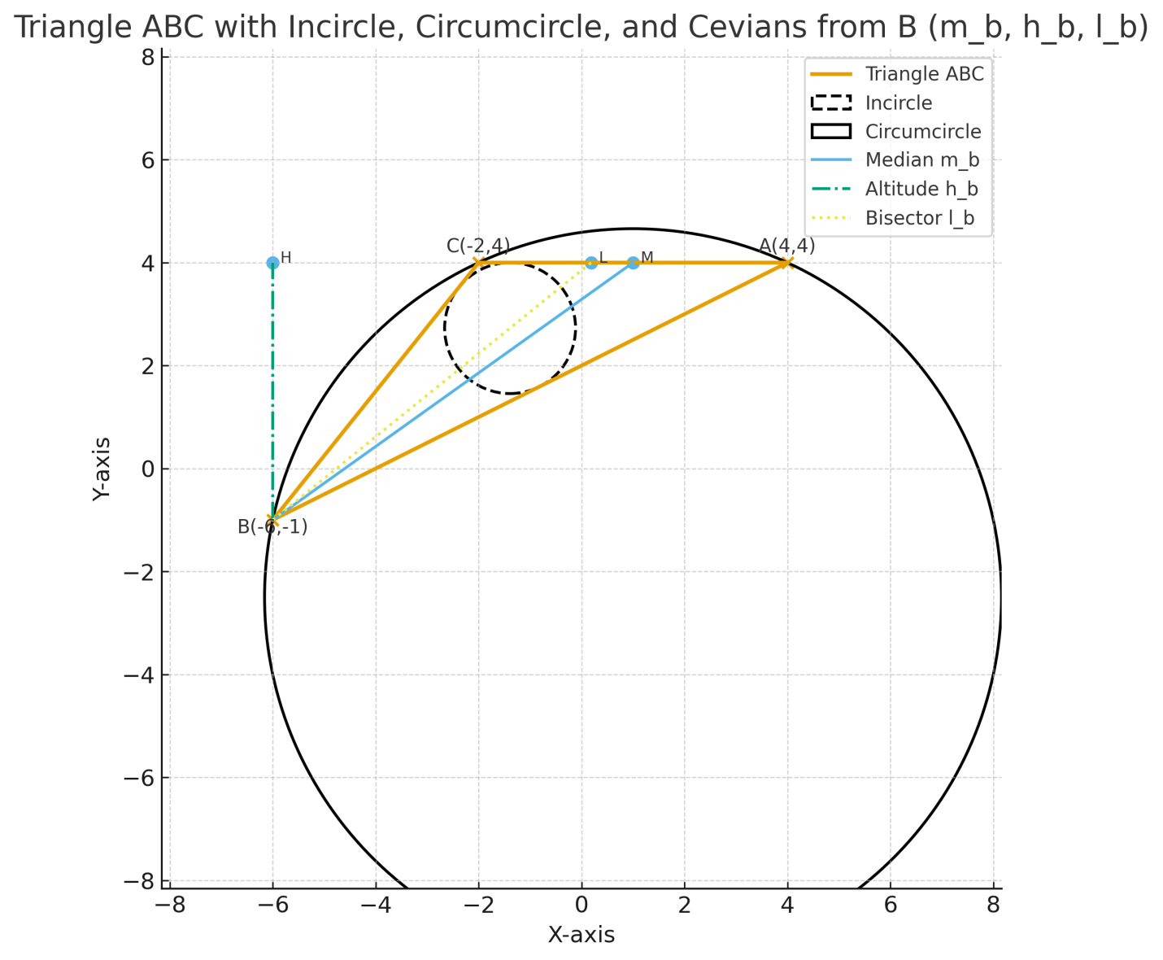

Q2. In 3D Euclidean space equipped with orthonormal frame, given a tetrahedron with vertices

$$Vectors: A(2,3,7), B(1,4,9), C( -4,0,5), D( -2,3, -5)$$
$$i)The perimeter, and angles of the face ABC$$
$$\vec{AB}=(-1, 1, 2)$$
$$\vec{AC}=(-6,-3,-2)$$
$$\vec{BC}=(-5,-4,-4)$$
$$\left|\vec{BC}\right|= \sqrt{{\left(-5\right)}^{2} + {\left(-4\right)}^{2} + {\left(-4\right)}^{2} }= \sqrt{25+16+16}=\sqrt{57 }=7.54983$$
$$\left|\vec{AC}\right|= \sqrt{{\left(-6\right)}^{2} + {\left(-3\right)}^{2} + {\left(-2\right)}^{2} }= \sqrt{36+9+4}=\sqrt{49}=7$$
$$\left|\vec{AB}\right|= \sqrt{{\left(-1\right)}^{2} + {\left(1\right)}^{2} + {\left(2\right)}^{2} }= \sqrt{6}=2.44949$$
$$Perimeter=7.54983+7+ 2.44949=16.99932 lu$$

$$Angle Face ABC$$

$$Angle at A$$
$$\vec{AB}. \vec{AC}=\left(-1\right)\left(-6\right)+\left(1\right)\left(-3\right)+\left(2\right)\left(-2\right)=\left(6-3-4\right)= -1$$
$$Cos A= \frac{-1}{7*\sqrt{6}}= -0.058321184$$
$$A={93.3}^{o}$$
$$Angle at B$$
$$\vec{BA}=\left(1,-1,-2\right)$$
$$\left|\vec{BA}\right|= \sqrt{{\left(1\right)}^{2} + {\left(-1\right)}^{2} + {\left(-2\right)}^{2} }= \sqrt{1+1+4}=\sqrt{6 }$$
$$\vec{BC}= (-5,-4,-4)$$
$$\left|\vec{BC}\right|= \sqrt{{\left(-5\right)}^{2} + {\left(-4\right)}^{2} + {\left(-4\right)}^{2} }= \sqrt{25+16+16}=\sqrt{57 }$$
$$\vec{BA}. \vec{BC}=\left(1\right)\left(-5\right)+\left(-1\right)\left(-4\right)+\left(-2\right)\left(-4\right)=\left(-5+4+8\right)= 7$$
$$Cos B= \frac{7}{\sqrt{57}*\sqrt{6}}= 0.378516649$$
$$B={67.7}^{o}$$
$$Angle at C$$
$$\vec{CA}=\left(6,3,2)\right)$$
$$\left|\vec{CA}\right|= \sqrt{{\left(6\right)}^{2} + {\left(3\right)}^{2} + {\left(2\right)}^{2} }= \sqrt{36+9+4}=\sqrt{49 }=7$$
$$\vec{CB}= (5,4,4))$$
$$\left|\vec{CB}\right|= \sqrt{{\left(5\right)}^{2} + {\left(4\right)}^{2} + {\left(4\right)}^{2} }= \sqrt{25+16+16}=\sqrt{57 }$$
$$\vec{CA}. \vec{CB}=\left(6\right)\left(5\right)+\left(3\right)\left(4\right)+\left(2\right)\left(4\right)=\left(30+12+8\right)= 50$$
$$Cos C= \frac{50}{\sqrt{57}*7}= 0.94609454$$
$$C={18.8}^{o}$$

$$ii) The area and volume of the tetrahedron$$
$$Cross product$$
$$\vec{AB }x \vec{AC }=\left|i j k -1 -6 1 -3 2 -2 \right|=i\left(1*-2-2*-3\right)-j\left(-1*-2+6*2\right)+k\left(-1*-3+6*2\right)$$
$$=i\left(-2+6\right)-j\left(2+12\right)+k\left(3-12\right)$$
$$=i\left(4\right)-j\left(14\right)+k\left(-9\right)$$
$$\vec{AB }x \vec{AC }=(4,-14,-9)$$

$$\left|\vec{AB }x \vec{AC } \right|= \sqrt{{\left(4\right)}^{2} + {\left(-14\right)}^{2} + {\left(-9\right)}^{2} }= \sqrt{293}$$

$$Area of Triangle ABC$$
$$Area= \frac{1}{2}\left|\vec{AB }x \vec{AC } \right|=\frac{1}{2}\sqrt{293} ≈8.5586$$
$$Volume of Tetrahedron ABCD$$
$$\vec{AB}=(-1, 1, 2)$$
$$\vec{AC}=(-6,-3,-2)$$
$$\vec{AD}=(-4,0,-12)$$

$V=\frac{1}{6}\left|-1 1 2 -6 -4 -3 0 -2 -12 \right|$
$$V=\frac{1}{6}\left(-1\left(-3 -2 0 -12 \right)-\left(-6 -2 -4 -12 \right)+2\left(-6 -3 -4 0 \right)\right)$$
$$V=\frac{1}{6}\left(-1\left(36-0\right)-\left(72-8\right)+2\left(0-12\right)\right)$$
$$V=\frac{1}{6}\left(-1\left(36\right)-\left(64\right)+2\left(-12\right)\right)$$
$$V=\frac{1}{6}\left(-36-64-24\right)$$
$$V=\frac{1}{6}\left(-124\right)= 20.66667 (Unit Cubic)$$

$$b) Use 3D Geo-Gebra to plot the tetrahedron$$
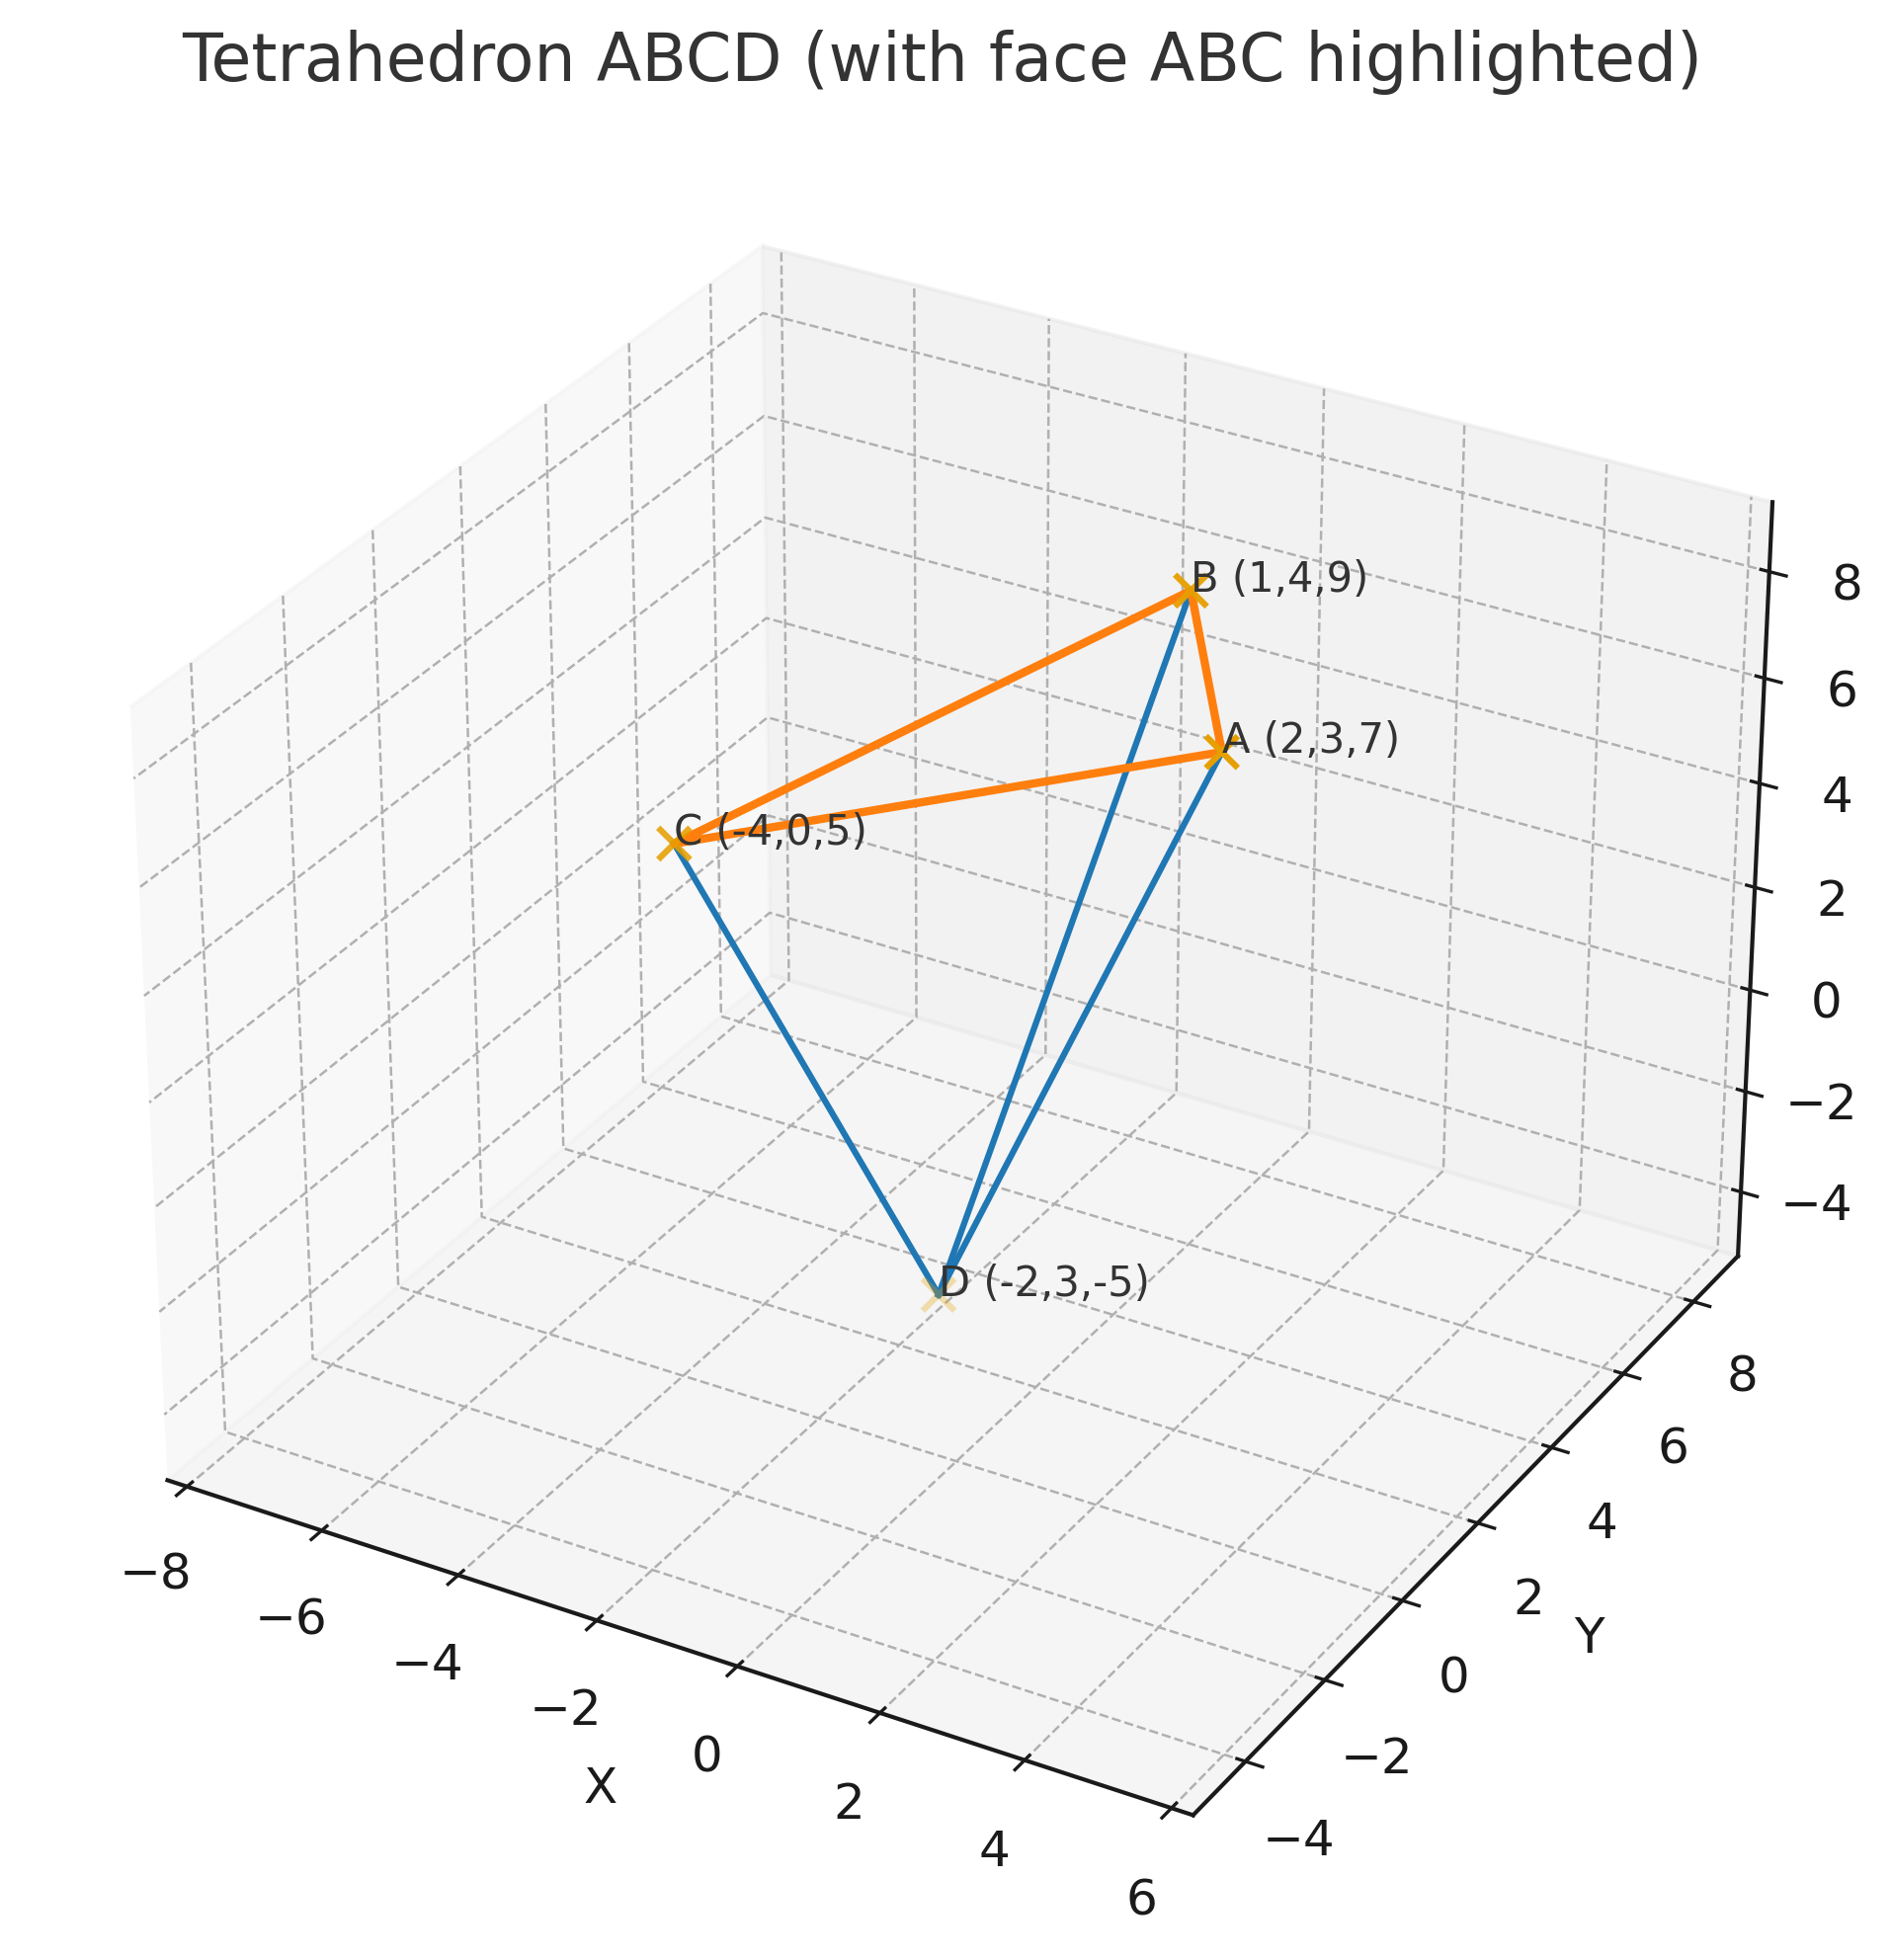

Q3. The polar coordinates of the end points of the segment AB are:

$$A \left(8,\frac{-2π}{3}\right),B \left(6,\frac{π}{3}\right)$$

$$Formula used$$
- $Length$

$$\left|AB\right|= \sqrt{{(x2-x1)}^{2}+ {(y2-y1)}^{2} }$$

- $Midpoint in Cartesian:$

$$M_{x}=\frac{x1+x2}{2},M_{y}=\frac{y1+y2}{2}$$

- $Convert midpoint to polar:$

$$r_{M}=\sqrt{M_{x}^{2}+M_{y}^{2 }}, θ_{M}=at(M_{y},M_{x})$$
$$a)Convert to Cartesian$$
$$for A$$
$$Cos\left(-\frac{2π}{3}\right)= Cos\left(\frac{2π}{3}\right)=- \frac{1}{2}$$
$$So,A_{x}=8\left(- \frac{1}{2}\right)=-4$$
$$Sin\left(-\frac{2π}{3}\right)= Sin\left(\frac{2π}{3}\right)=- \frac{\sqrt{3}}{2} So,A_{y}=8\left(- \frac{\sqrt{3}}{2}\right)=-4\sqrt{3}$$
$$Thus A = \left(-4,-4\sqrt{3}\right)$$
$$for B$$
$$Cos\left(\frac{π}{3}\right)= \frac{1}{2}$$
$$So,B_{x}=6\left( \frac{1}{2}\right)=3$$
$$Sin\left(\frac{π}{3}\right)= \frac{\sqrt{3}}{2} So,B_{y}=6\left( \frac{\sqrt{3}}{2}\right)=3\sqrt{3}$$
$$Thus B = \left(3,3\sqrt{3}\right)$$

$$b)Find the length of the segment$$
$$\left|AB\right|= \sqrt{{(3+4)}^{2}+ {(3\sqrt{3}-(-4\sqrt{3})}^{2} }=\sqrt{49+ 147 }=\sqrt{196}=14$$

$$c)Midpoint in Cartesian$$
$$M_{x}=\frac{-4+3}{2}=\frac{-1}{2} ,$$
$$M_{y}=\frac{-4\sqrt{3}+3\sqrt{3}}{2}=\frac{-\sqrt{3}}{2}$$
$So M=\left(\frac{-1}{2},\frac{-\sqrt{3}}{2}\right)≈(-0.5,-0.866025)$
$$d) Midpoint in Polar:$$
$r_{M}=\sqrt{{\left(\frac{-1}{2}\right)}^{2}+{\left(\frac{\sqrt{3}}{2}\right)}^{2}}=\sqrt{\left(\frac{1}{4}\right)+\left(\frac{3}{4}\right)} = \sqrt{1}=1$
$$θ_{M}=\tan^{-1}\left(\frac{-\sqrt{3}}{2} ,\frac{-1}{2}\right)$$
$$\tan^{-1}\frac{M_{y}}{M_{x}}= \tan^{-1}\frac{-\sqrt{3} /2}{-1/2}=\tan^{-1}\sqrt{3}=\frac{π}{3}$$
$$θ_{M}=-\frac{π}{3} . Angle in radians ≈ -2.094395102$$

$$C)Plot the above given segment and its mid-point$$
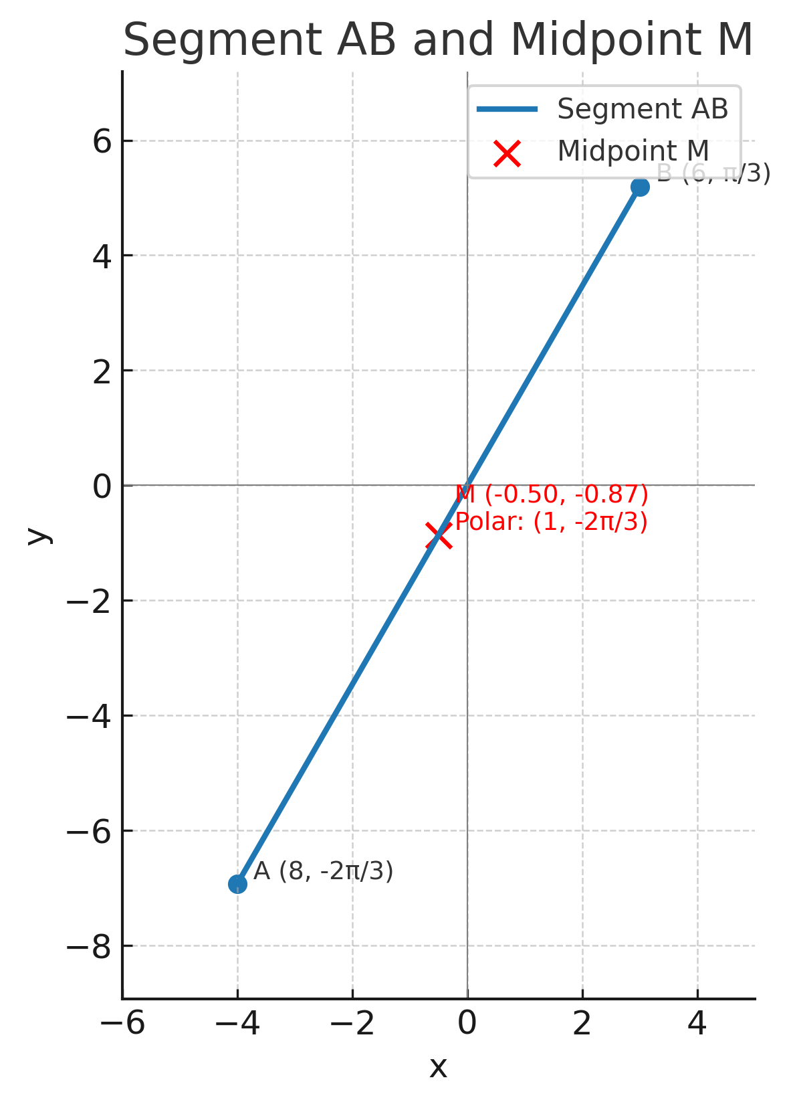

Q4. Use 2D-Geogebra and plot on the same chart the graphs of the following 2d-curves expressed in polar coordinates.
$$r=3(1±coscos θ ); r=3(1±coscos θ )$$
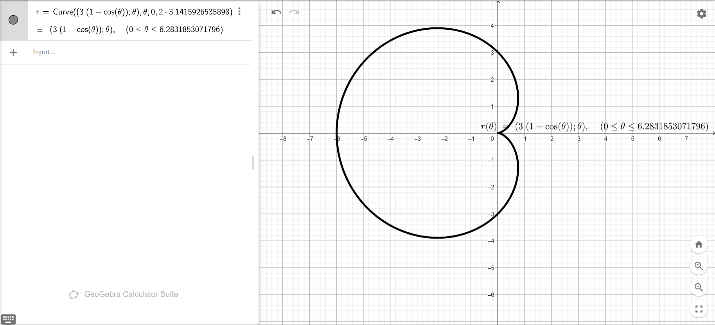

$$r=6coscos 2θ ; r=6sinsin 2θ )$$
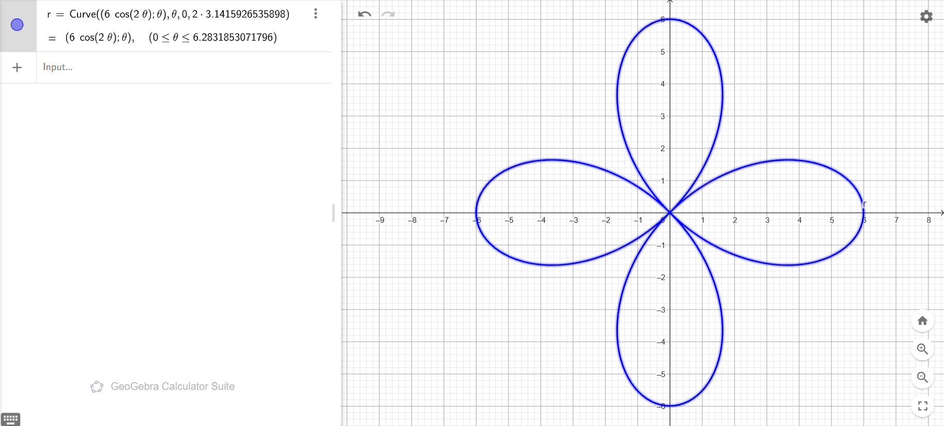
$$r=0.125θ; r=2^{-θ}; r=2^{θ}$$
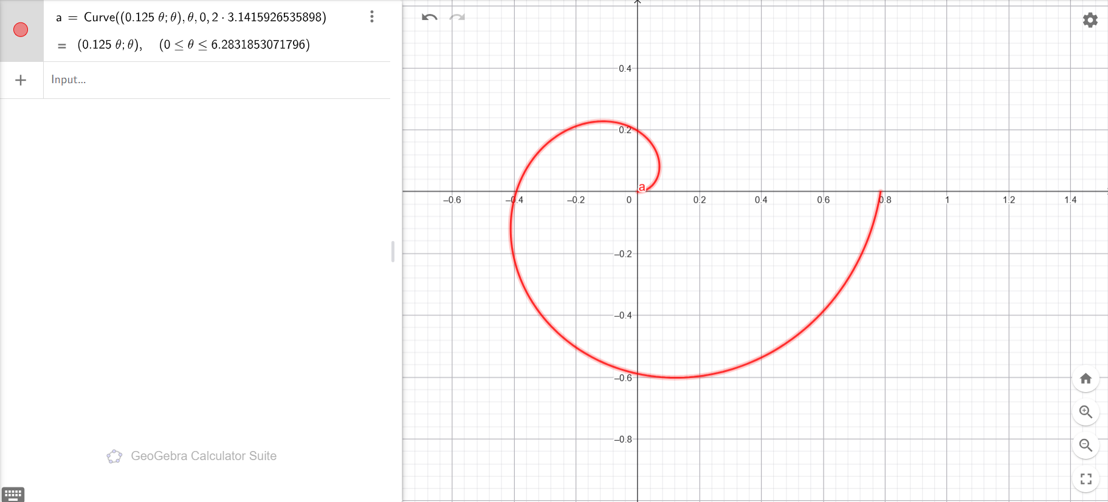

$$r=4\sqrt{cos2θ}; r=4\sqrt{sin2θ}$$
